Life Cycle Selection Guidelines

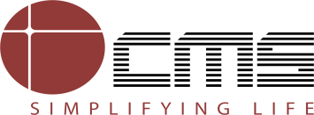

Revision History

Version Number | Creation/  Revision Date | Prepared /Updated By | Reviewed By | Approved By | Change Description
1.0 | 18.04.2023 | Rajashree M. | Jayanta C. | Jayanta C. | Baseline Version

Table of Contents

1 Purpose 4
2 Scope 4
3 Definitions & Acronyms 4
4 Guidelines Description 4
4.1 Identification of Project Type 4
4.2 Life Cycle Model selection Criteria for Execution 5
4.2.1 The Waterfall Model 6
4.2.2 Incremental Model 7
4.2.3 Spiral 8
4.2.4 V- Model 8
4.2.5 Prototyping 9
4.2.6 RAD 10
4.3 Development Phases 11
4.3.1 User Requirements / System Conceptualization 11
4.3.2 Software Requirement Specifications (SRS) / System Analysis 12
4.3.3 Designing 12
4.3.4 Coding 12
4.3.5 Testing 12
4.3.6 Delivery 13
4.3.7 Implementation (includes Acceptance Testing by client) 13
4.3.8 Maintenance 13

1 Purpose

This Guideline document discusses the concepts behind the design of software life cycle models (SLCMs). It provides an overview of the various life cycle models and provides guidance to adopt suitable life cycle model for the project. With this information you can:
- Create a custom SLCM for your project
- Tailor an existing SLCM
- Evaluate an SLCM

2 Scope

This document covers the definition of life cycle, the various models available and when to use those models for all types of software projects executed.

3 Definitions & Acronyms
ACRONYM/ ITEM | DEFINITION/ DESCRIPTION
DBMS | Data Base Management System
HLD | High Level Design
LLD | Low Level Design
RAD | Rapid Application Development
SLCM | Software Life cycle Model

4 Guidelines Description

4.1 Identification of Project Type
The projects executed by are broadly classified as Development and Maintenance projects. The following objective criteria may be used to arrive at the classification of projects.
Criteria table for classifying projects as Development/ Maintenance type

Project Type is classified as | Objective Criteria
Project Type is classified as | Application/ System | Functionality | Design | Hardware Platform | Software Platform
Development | Not Existing | New | New | Any Platform | Any Platform
Development | Existing | New | New | Same/ Different Platform | Same/ Different Platform
Development | Existing | New | Existing with modifications | Same/ Different Platform | Same/ Different Platform
Development | Existing | Same | New | Same/ Different Platform | Different Platform
Development | Existing | Same | Existing with modifications | Same/ Different Platform | Same/ Different Platform
Maintenance | Existing | Old with additions/ modifications and fixing defects | Existing with modifications | Same Platform | Same Platform
Software Platform column in the above table, for Existing application/ Systems, is defined as the different platform for the following cases-

No. | Existing Application/ System | Target Application/ System
1 | Character Based User Interface | Graphical User Interface
2 | Flat file | DBMS
3 | On line System | Web Based System
4 | Change from one type of DBMS to another DBMS i.e., Hierarchical (H), Network (N) or Relational (R)
4.1 | Hierarchical Database Management System (HDBMS) | Relational Database Management System (RDBMS)
4.2 | Hierarchical Database Management System (HDBMS) | NDBMS
4.3 | Network Database Management System (NDBMS) | RDBMS

4.2 Life Cycle Model selection Criteria for Execution

Different Projects have different needs, even if they all have to be developed quickly. To choose the most effective lifecycle for a project, examine the project and various conditions.
For the identified project, each Project condition is rated as Poor, Fair, and Excellent. These Actual identified Ratings for each project condition are compared with the models given in the table below and the Model for which most of the Ratings of the conditions matches, may be selected as the Project Execution Life Cycle Model.

The actual effectiveness of any lifecycle model may even be worse than the table indicates. On the other hand, if the model is weak in a particular area, that weakness can be addressed / attended to, early in the planning stage and compensated for, perhaps by creating a hybrid model using one or more of the models described. Many of the table's criteria will also be strongly influenced by development considerations other than the choice of lifecycle models.

 | Life cycle Model’s effectiveness
Project Conditions | Waterfall | Incremental | Spiral | V Type | Prototype and RAD | SCRUM
Work with poorly understood requirements | Poor | Excellent | Excellent | Poor | Fair | Fair to Excellent
Work with poorly understood architecture | Poor | Excellent | Poor to Fair | Poor | Excellent | Excellent
Produce a highly reliable system | Excellent | Excellent | Fair | Excellent | Excellent | Excellent
Produce a system with large growth envelope | Excellent | Excellent | Fair | Excellent | Excellent | Fair to Excellent
Can be constrained to a predefined schedule | Fair | Poor to Fair | Fair | Fair | Fair | Fair
Allows for significant midcourse corrections | Poor | Fair | Fair | Poor | Excellent | Excellent
Provides customer with progress visibility | Poor | Excellent | Excellent | Poor | Excellent | Excellent
Provides management with progress visibility | Fair | Excellent | Fair to Excellent | Fair | Excellent | Excellent
Work with inadequate resources | Poor | Fair | Fair | Poor | Excellent | Excellent
Work with complex requirements | Poor | Fair | Fair to Excellent | Poor | Fair to Excellent | Fair to Excellent
Work with new technology (to the organization) | Poor | Fair | Excellent | Poor | Excellent | Excellent
Work in a new functional domain (to the organization) | Poor | Fair | Excellent | Poor | Fair to Excellent | Fair to Excellent

4.2.1 The Waterfall Model

The waterfall model is just a time-ordered list of activities to be performed to obtain an IT system. This model was and remains relatively popular. However, it is quite rare that a software project will follow these steps exactly. In addition, unlike prototyping or other methodologies, it does not allow for feedback loops. The project takes a "Straight line" path. The different phases are explicitly recognized and the subsequent phase starts only after completion of the previous phase. This means that, for example, once the requirements are written, they should be stable throughout the project. Any reviewing of them is thus an extraneous and unplanned activity.

Client sign off for user requirements and subsequent documents up to the design stage (where feasible) should be taken to ensure clarity in requirements and reduce subsequent changes and rework. Alternatively, client feedback may be taken from time to time.
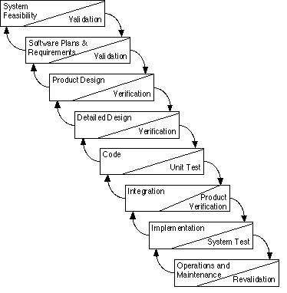
The procedures applicable for various phases in this model are:

Usage - Waterfall model is suitable for small projects and projects where the user needs are clearly specified.

4.2.2 Incremental Model
Incremental Model is like an iterative Waterfall model, with new iteration taking up new functionality. Typically in this model, the core of the application is built initially and components are added to it periodically. This permits gradual implementation of the system in small installments and reduces implementation risk.

The obvious advantages are savings on implementation resources, early operation of the system and reduction in the impact of project failure.

All phases will be similar to Waterfall Model, but restricted to a particular module. Based on the logical ERD, a base physical data model is created and construction phase starts after that. Completion of design for each module may result in change in database and may also impact some already completed modules. For such impacted modules, design will be updated and again the build and corresponding phases will start.

On completion of all the modules, integration testing is done. It is possible to have iteration of integration testing also. This can happen if a project is broken up in delivery phases with critical and dependent modules being taken up in earlier phases.
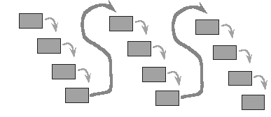
The processes applicable for various phases in this model are:
Usage - This model can be used for a project of any size where the application can be developed in a modular fashion with minimum interdependency.

4.2.3 Spiral
This model goes through a cycle - Requirements-Quick Design-Construct-Test-Evaluate - a number of iterations until the product is acceptable to the client in terms of meeting the objectives and the functional requirements. The project begins with requirements gathering concentration on the purpose and scope of the prototype. A quick design focusing on representation of the core aspects of the system is prepared and documented. The criteria for start / end of iteration and the final cut are also documented. Major functions are developed early in the project schedule. Since continuous feedback is taken from the client, additional functionality may be added from time to time, as the product takes shape. Once the product is accepted, the other activities of documenting the system and implementation are performed. The processes applicable for various phases in this model are:

Usage - This model is used when the user is not clear about his requirements. The prototype helps the user get a feel of the system. With continuous feedback from the client and subsequent refinement of the prototype, the final application meeting client requirements is developed.

4.2.4 V- Model

The V-Model framework is a structured testing approach that can be used with any project management or system development methodology. The framework emphasizes quality from the initial requirements stage through the final testing stage. It focuses on testing throughout the development lifecycle, early development of test requirements, and early detection of errors. Each major deliverable in the development process is assessed, verified, validated and tested.
-Verification- Checks that a deliverable is complete (contains all requires information, follows standards)
-Validation- Checks that the deliverables satisfy requirements specified in the previous stage or an earlier stage, and that the business case is met.
-Testing- ensures that the specification is properly assembled and implemented.
The deliverables of each stage need to be verified and validated to ensure that they are complete and correct. Work proceeds to the next stage in the V-Model when all project deliverables in a stage have met all verification and validation requirements. The process of verification and validation is an attempt to catch as many errors as possible within the development life cycle, otherwise known as “stage containment”. Each successive stage of testing ensures that the specifications defined in the deliverables of the corresponding stage have been implemented. This is achieved by the early development of test requirements.

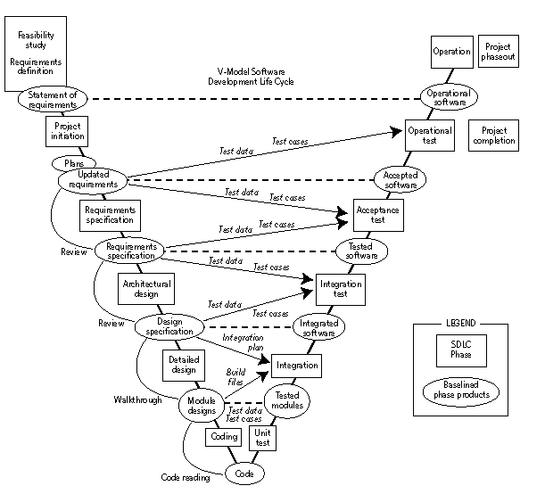

4.2.5 Prototyping
A prototype is a miniature version of an end product. It is an executable version of an actual product, incorporating key elements of the final version but is incomplete in terms of functionality, and robustness. This concept of prototype is illustrated in figure 1 below:
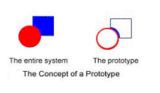
In a nutshell, it is a design methodology that allows the designer to build a prototype, test and modify it, and through an iterative process, complete the final product. The model can be presented as the following events:
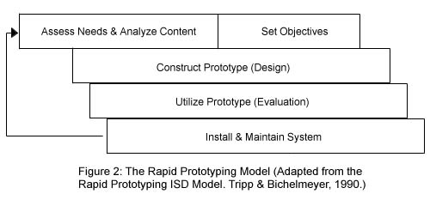
The prototyping strategy is increasingly being used. It gives a feel of the product in the early stages and how it will work in the future. It is also a useful model when -
- There is a requirement to demonstrate feasibility of a core concept / design attribute.
- There is a requirement to demonstrate the user interface or a subset of the total requirements.
- There is a need to elicit a market response.
- Requirements are not clear and they have to be elicited interactively for freezing the user requirements.
End users who make recommendations about requirements review the prototype system. The prototype is then enhanced or refined to reflect end users requirements. Prototyping makes such revisions possible.

4.2.6 RAD
The project begins with requirements gathering concentration on the purpose and scope of the application. A quick design focusing on representation of the core aspects of the system is prepared and documented. The prototyping tool is used to create screens or reports using case tools along with navigation headings, comments, help messages and error messages. Once this is completed, the screens are demonstrated to end-users and normal operation is simulated. The end users provide feedback about what needs to be added, deleted or changed. This may go through a few iterations before the design is finalized. Once the design is approved, the code is generated in the suitable technical environment.
Usage - When CASE (Computer Assisted System Engineering) tools or front-end tools like Visual Basic, Power Builder or Developer 2000 are being used and the user knows the requirements, this type of prototyping is used.

4.2.7 SCRUM
Scrum is a framework for running projects that is based on agile principles and values. It defines a set of activities that can help your team deliver more value to your customers faster. These activities provide your customers with the opportunity to review, guide and influence your team’s work as it progresses. This approach does not attempt to define everything at the start of a project. Instead, your team works in short iterations (also called sprints) and refines the plan as the team makes progress. In short, “Scrum is an Innovative Approach to Getting Work Done”

The Scrum Framework:
- A product owner creates a prioritized wish list called a product backlog.
- During sprint planning, the team pulls a small chunk from the top of that wish list, a sprint backlog, and decides how to implement those pieces.
- The team has a certain amount of time, a sprint, to complete its work – usually two to four weeks – but meets each day to assess its progress (daily scrum).
- Along the way, the Scrum Master keeps the team focused on its goal.
- At the end of the sprint, the work should be potentially shippable, as in ready to hand to a customer, put on a store shelf, or show to a stakeholder.
- The sprint ends with a sprint review and retrospective.
- As the next sprint begins, the team chooses another chunk of the product backlog and begins working again.
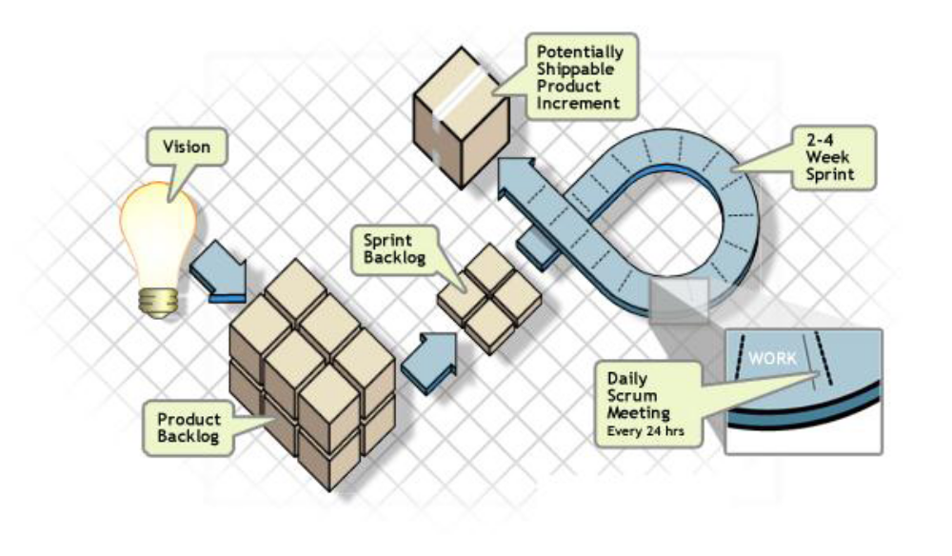
Figure 1.0 SCRUM LIFE CYCLE
The cycle repeats until enough items in the product backlog have been completed, the budget is depleted, or a deadline arrives. Which of these milestones marks the end of the work is entirely specific to the project. No matter which impetus stops work, Scrum ensures that the most valuable work has been completed when the project ends.

4.3 Development Phases

4.3.1 User Requirements / System Conceptualization
This activity refers to the understanding of all aspects of the targeted business function or process, with the goals of determining how each of those aspects relates with one another, and which aspects will be incorporated into the system. Project Acquisition process is applicable here.

4.3.2 Software Requirement Specifications (SRS) / System Analysis
This step refers to the gathering of system requirements, with the goal of determining how these requirements will be integrated in the system. Extensive communication between the customer and the development team is essential. Software Requirement Specifications (SRS) process is applicable here.

4.3.3 Designing
Once the Software requirement specifications (SRS) have been collected and analyzed, it is necessary to identify in detail how the system will be constructed (e.g. Architecture and details) to perform the necessary tasks. More specifically, the Design phase is focused on translating SRS to design specifications, which facilitates direct coding as part of software construction. Designing- High level and Low Level Processes are applicable here.

4.3.4 Coding
Also known as programming, this step involves the creation of the system software. Design Specifications are translated into computer code. This also includes the steps for reviewing the code and unit testing. The development process is applicable here.

4.3.5 Testing

As the software is created and added to the developing system, testing is performed to ensure that it is working correctly and efficiently. Testing is generally focused on two areas, internal efficiency and external effectiveness. The goal of external effectiveness testing is to verify that the software is functioning according to system design, and that it is performing all the required functions. The goal of internal testing is to make sure that the computer code is efficient, standardized, and well documented. Testing can be a labor-intensive process due to its iterative nature. The different levels of testing include Integration testing, system testing and acceptance testing.

Integration Testing

Integration testing should cover the following aspects of the module’s functionality:
- Exercise all interfaces between units within a module whether new or modified. Exercise each new or modified function or user input command and each command option.
- Interface as expected with each database, database table, utility, external software package or external file, mainframe, server, hardware device or other entities external to the module.
- Verify the correct generation of all error or warning or other user or log messages.
- Once a module has been tested successfully it can be certified and approved by the team lead or project lead or test team lead.

System Testing

System testing is the development and test team’s last opportunity to identify problems and verify the validity of solutions implemented in previous stages. System tests should be as close to operational as possible, simulating usage or mission conditions as realistically as the schedule will permit. One of the key derivatives of system testing is the verification that all functionality specified in the requirements works and that the various functions work together.
- In the test phase, units are combined into modules, which are tested during integration testing with other modules, and certified at the module level.
- Test plans and processes are developed and followed to insure that all requirements are being tested and verified. Modules are combined to make up a build, which is tested in turn and certified. Multiple builds may be integrated and tested before a deliverable release is produced.

4.3.6 Delivery

The delivery phase involves the preparation, review and execution of a Delivery.

4.3.7 Implementation (includes Acceptance Testing by client)

Acceptance testing is based primarily upon use case scenarios. Acceptance tests should include those user interactions for which the system may not have been specifically designed, but could possibly occur during system use. Acceptance test plans should be developed not so much with the concept of testing proper system use, but also testing improper use of system functionality.
This phase identifies the required personnel, equipment, preparations and software necessary for a smooth transition from the Software development phase to maintenance phases of the project.
The implementation phase involves the provision of Training to Client/customer, Set up of Environment for Acceptance testing (if required), Correction of notified Defects (if any), installation of product at customer end.

4.3.8 Maintenance
Software maintenance requires the use of problem and change request tracking database. Software problems are reported either by end users or developers. Problems or change requests are assigned severity levels and allotted to a particular build in the same way that requirements are allotted to builds. A Configuration management (covering change request) process is followed for devising solutions, implementing the solution and verifying and testing the results.

